# ST.XAVIER’S COLLEGE

# MAITIGHAR, KATHMANDU



**ASSIGNMENT #8**

**Database Management System**

**Submitted By:**

Pratibha Panta

012BSCCSIT028

4th Sem, 2nd Year

**Submitted To:**

______________________

Er. Sanjay Kumar Yadav

Department of Computer Science

Lecturer

**4.2 Data Definition Language**

A DDL is a language used to define data structures and modify data. For example, DDL commands can be used to add, remove, or modify tables within in a database. DDLs used in database applications are considered a subset of SQL, the Structured Query Language. A Data Definition Language has a pre-defined syntax for describing data.[1]

For example, to build a new table using SQL syntax, the CREATE command is used, followed by parameters for the table name and column definitions. The DDL can also define the name of each column and the associated data type. Once a table is created, it can be modified using the ALTER command. If the table is no longer needed, the DROP command can be used to delete the table.[1]

Since DDL is a subset of SQL, it does not include all the possible SQL commands. For example, commands such as SELECT and INSERT are considered part of the Data Manipulation Language (DML), while access commands such as CONNECT and EXECUTE are part of the Data Control Language (DCL). The DDL, DML, and DCL languages include most of the commands supported by SQL.[1]

**4.2.1 Domain Type in SQl**

1. The SQL standard supports a variety of built-in domain types[3]:
   * **char**(n) (or **character**(n)): fixed-length character string, with user-specified length.
   * **varchar**(n) (or **character varying**): variable-length character string, with user-specified maximum length.
   * **int** or **integer**: an integer (length is machine-dependent).
   * **smallint**: a small integer (length is machine-dependent).
   * **numeric**(*p, d*): a fixed-point number with user-specified precision, consists of *p* digits (plus a sign) and *d* of *p* digits are to the right of the decimal point. E.g., **numeric**(*3, 1*) allows 44.5 to be stored exactly but not 444.5.
   * **real** or **double precision**: floating-point or double-precision floating-point numbers, with machine-dependent precision.
   * **float**(n): floating-point, with user-specified precision of at least *n* digits.
   * **date**: a calendar date, containing four digit year, month, and day of the month.
   * **time**: the time of the day in hours, minutes, and seconds.
2. allows arithmetic and comparison operations on various numeric domains, including, **interval** and *cast* (*type coercion*) such as transforming between *smallint* and *int*. It considers strings with different length are compatible types as well.
3. allows **create domain** statement, e.g.,

**create domain** *person-name* **char**(20)

4.2.2 Schema Definition in SQL

In computer programming, a schema (pronounced SKEE-mah) is the organization or structure for a database. The activity of data modeling leads to a schema. (The plural form is schemata. The term is from a Greek word for "form" or "figure." Another word from the same source is "schematic.") The term is used in discussing both relational databases and object-oriented databases. The term sometimes seems to refer to a visualization of a structure and sometimes to a formal text-oriented description.[3]

4.3 Data Manipulation Language

Data Manipulation is:**retrieval** of information from the database, **insertion** of new information into the database, **deletion** of information in the database and **modification** of information in the database[4]

A DML is a language which enables users to access and manipulate data.

The goal is to provide efficient human interaction with the system.

There are two types of DML:

**procedural:** the user specifies what data is needed and how to get it

**nonprocedural:** the user only specifies what data is needed, Easier for user, may not generate code as efficient as that produced by procedural languages

**4.3.1 The Select Clause**

Specifies the columns to be returned by the query.

**Syntax**

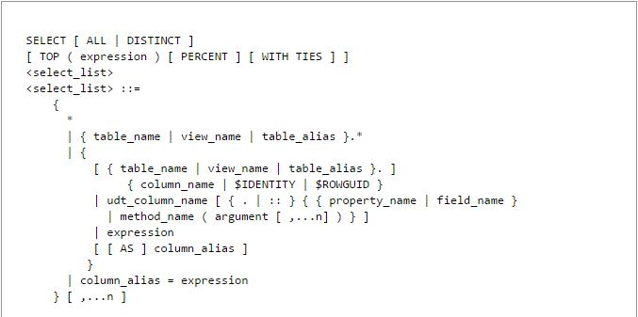

4.3.2 The where clause

The WHERE clause is used to extract only those records that fulfill a specified criterion.

Syntax

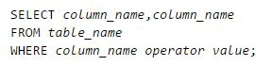

4.3.3 The form Clause

4.3.4 The Rename Operation

4.3.5 Tuple Variable

4.3.6 String Operation

4.3.7 Ordering the display of Tuples

4.3.8 Duplicate Tuples

Reference

[1] <http://techterms.com/definition/ddl>

[2] <http://www.cs.sfu.ca/CourseCentral/354/zaiane/material/notes/Chapter4/node31.html>

[3] <http://searchsqlserver.techtarget.com/definition/schema>

[4] <http://www.cs.sfu.ca/CourseCentral/354/zaiane/material/notes/Chapter1/node17.html>